Contents
Overview 1
Shift Types and Daily Work Patterns 1
Rotating/flexible shift patterns 2
Generating a shift type code 2
Creating a new weekly shift Pattern 2
Creating a new Rotating shifts 3
How to Copy a shift 5
How to De-activate a shift 5

Overview
The Shift Type configuration screen is available via Portal on the WFM Admin Dashboard.
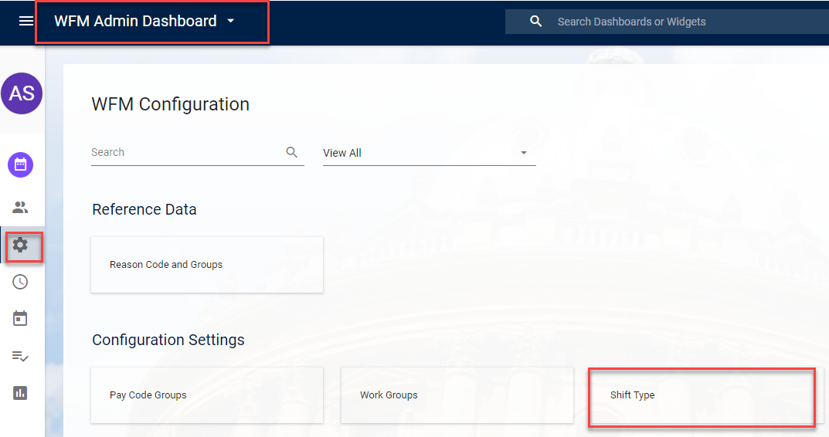

The following menu profile should be assigned in order to gain access to the steps below.
- WFM_SHIFTS_TYPES

A shift type determines the hours an employee is contracted to work. Departmental HR Administrators assign the appropriate shift types to appointments via People Management > Work Schedule, but can only assign shift types that have been created by HR Systems.

Shift Types and Daily Work Patterns
Shift Types are formed by assigning a work pattern to each day of the week. A work pattern is the number of hours worked in a day, the start and end times are irrelevant, so an employee working 5 hours on a Monday starting at 08:00AM would require the same work pattern as an employee working 5 hours on a Monday starting at 11:00AM.
Work patterns are broken into 3 minute intervals (the lowest number that can be accurately decimalised). The largest work pattern available is a 13 hour day.
On days when employees are not required to work the ‘REST’ work pattern is used.

Rotating/flexible shift patterns
Most employees follow the same pattern each week. If an employee varies between different patterns each week see part B.
If an employee has a flexi-time arrangement, where there is no predefined pattern, they should be assigned one of the standard shifts based on their average daily hours. For example, if someone works 25 hours across 5 days, they should be assigned a shift type with a 5 hour work pattern on each day, Monday-Friday.
Departmental HR should request a new shift type via OSM service request and provide a copy of the Shift Code Generator for the shift type required.

Generating a shift type code
Each shift type has a unique code and a name (description). The codes for weekly shift patterns are generated using the Shift Type Code Generator, with each code represents a unique combination of daily work patterns. This prevents multiple shift types being created with the same pattern. Codes for Rotating shift types are linked to the employee appointments.

Creating a new weekly shift Pattern
Check if the shift code has already been created.
Click Add and complete the following fields.
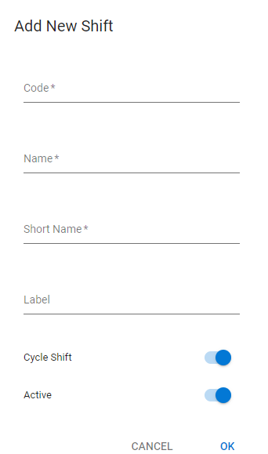
- Code - paste the Shift Code into this field
- Name - Enter a description of the shift into the name field. The description will help the HR Administrators to assign the correct shift (limited character count (40) it is not always possible to fully describe the pattern)
Examples: PT_10Hrs_Mon-Fri_2Hrs or PT_26Hrs_Mon-7.5_T_3.5_W_3.5_Thu_9Hrs
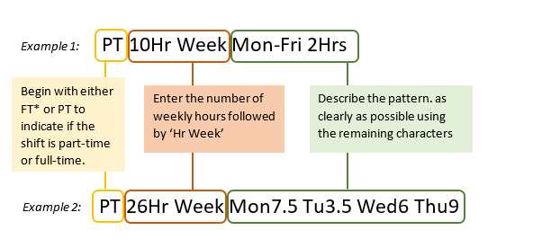

- Short Name - always N/A
- Label – Leave Blank
As part of the enhancement of the screens from Back Office to Portal, there is now a free text label which can be used on a shift type in order to easily identify it.
This can also be used to group all the shifts together if needed. For example, if there was a need to keep together all of the Cork shifts, you can use the free text label to name the shift.
While searching for a shift type the user is able to easily search for the code, description or the label assigned to the Shift Type. There can be multiple shifts assigned to the one label. You can search for the specific label and the search will return all shifts with the specific label attached.
- Cycle Shift and Active are set by default.
The Shift Patterns screen will open up. Click ADD and fill in the hours as per the working shift submitted. The Seq ‘Seq No.’ will pre-populate as 1.
NOTE: Any days without hours (including SAT and SUN) must be set to ‘REST’ as per example below:
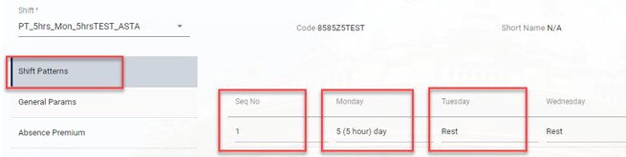

Creating a new Rotating shifts
Click Add and complete the following fields.

- Code:
Rotating shift type codes follow the format: RT<APP. ID><VERSION LETTER>
For example: Code - RT12345-1A
Term-Time Only shift type codes follow the format: TT<APP. ID><VERSION LETTER>
For example : TT15432-1B

- Name - The description should include Appointment ID and Personnel No. will help HR assign the correct shift

Rotating shifts should follow the format:
R##.##HRS <APP.ID> <PERSONNEL No.> <VERSION LETTER>
If the number of hours differs each week, you can insert the word average.
R##.##HRS Average <APP.ID> <PERSONNEL No.> <VERSION LETTER>
Example: R_30Hrs_Average_12345-1A_1234567A

Term-Time only shifts should follow the format:
TT##.##HRS <APP.ID> <PERSONNEL No.> <VERSION LETTER>
If the number of hours differs each week, you can insert the word average.
TT##.##HRS Average <APP.ID> <PERSONNEL No.> <VERSION LETTER>

- Short Name - always N/A
- Label – Leave Blank
- Cycle Shift and Active are set by default.
The Shift Patterns screen will open up. Click ADD and fill in the hours as per the working shift submitted. The Seq ‘Seq No.’ will pre-populate as 1.
NOTE: Any days without hours (including SAT and SUN) must be set to ‘Rest’
Click ADD to repeat for the other weeks in the rotating pattern, the sequence number will increase with each row.

How to Copy a shift

If you wish to Copy a shift, complete the following:
Search for the shift you wish to copy, and select Copy via the three breadcrumbs. Only the shift pattern will copy in.

How to De-activate a shift
In certain circumstances, you may wish to de-activate a shift, if it is one which you are no longer using. This means the shift will no longer display on the dropdown lists across the system as an available shift.
When you try to de-activate a shift, you receive the following message:
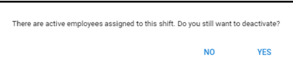
NOTE: You can mark a shift as inactive where there are employees assigned to it but you will not have be able to delete it.

